Furniture Store Website

# Overall Concept

This project will be a full stack website that allows the public to sign up, log in, and then search for and buy Home Furniture (Sofas, Couches, Dining Tables, Chairs etc). It will have the following features:

* Two types of users:
  + Administrator:
    - The site will have one administrator that logs in with the username “admin” with a password set by environmental configuration (not hardcoded).
    - The administrator has the ability to add items to the library.
  + Regular User:
    - Regular users register for the site by entering in their details and passwords. They log into the site via email and password stored in the database. Passwords are salted in the database.
    - They can browse the site, or search the site for items to buy
    - When logged in, they can buy items.
    - When an item is out of stock, they can place pre order on those items and be notified when the item becomes available and the item immediately gets bought.
* The main purpose of the site is to find (by browsing or searching) and buy furniture:
  + All of the details for the furniture items are stored in the database
  + Records of what is in stock, and what has pre orders placed on are stored in the database.
  + The database is searchable
    - The users can do a simple text search that searches all fields in the database
    - The users can also click the search link to go to an advanced search page where they can search by individual fields (content type: furniture type, style, name, manufacturer, category: dining room, living room, kitchen etc., description)
  + **Users buy furniture items by clicking the buy button on an item when browsing the site, bought items are removed from the available stock, the system will email a user to tell them that an item has been bought as well as when it is restocked when pre-ordered:**
    - **The site must implement the email functionality, send an email to the user with details on the furniture item**
  + Users can pre order items that are out of stock. When the item is restocked the sale is completed at the time of restocking.

# Pages

The site must have the following minimum set of pages / behaviour:

* **Main page:** This page lets even non-logged in users browse the items in the store, it allows users to login or signup, and also lets users do simple text searching of the database.
* **Main page (Administrator mode):** When logged in as the administrator the main page shows two links to administrator only pages: the add item page and the stock management page.
* **Login page:** User can log into the system, after logging in successfully they are redirected to the main page.
* **Register / signup page:** User can sign up as a new user entering all their details, after signup they are redirected to the main page.
* **Administrator add item page:** Through this page administrators can add items to the store. Once added the item should show up when browsing or searching the site.
* **Administrator stock management page:** Administrators go through the physical items inventory and record it to update the database and allow them to be bought by other users. This page shows all current stocks in the system and allows the administrator to restock those items.
* **Item details page:** This page has all the details of a store item and provides a button to either borrow or place a hold on that item.
* **Search results page:** Whether a user does an advanced search, or a simple text search this page lists all store items that matched their search
* **Advanced search page:** This page allows users to search by specific fields in the database (content type: furniture type, style, name, manufacturer, category: dining room, living room, kitchen etc., description)
* **Browse page:** This page allows users to browse the entire inventory of the store, by furniture type (sofas, couches, tables), category (dining room, living room, kitchen etc.). The entire contents of the store are organized in a tree structure and this page allows users to browse that structure. When they select a leaf node in the structure they will then see all items that match the restriction.

# Main Page:

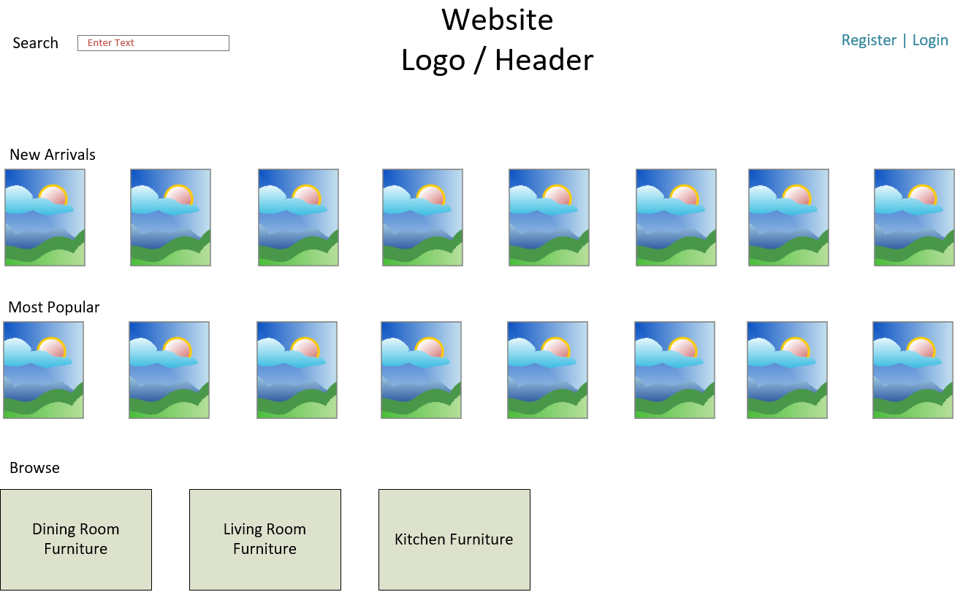

The main page has the following functionality:

* The ability to login or register for the site (link to other pages)
* A logo with the site’s name
* A simple text search box, the search text would be clickable to go to an advanced search page with the ability to search each individual field in the database.
  + Searching takes you to a search results page which lists any items that match your search
* The New Arrivals section lists the newest X (where X is configurable) items added to the store, showing the photo for the item and some way of knowing if what kind of furniture it is.
* The Most Popular section lists the X (where X is configurable) items that are the most popular at the store (as determined by number of orders + number of pre orders).
* The Browse section has logos to take them to the browse page for Dining room, Living Room, Kitchen furniture.

# Main Page (Administrator Mode):

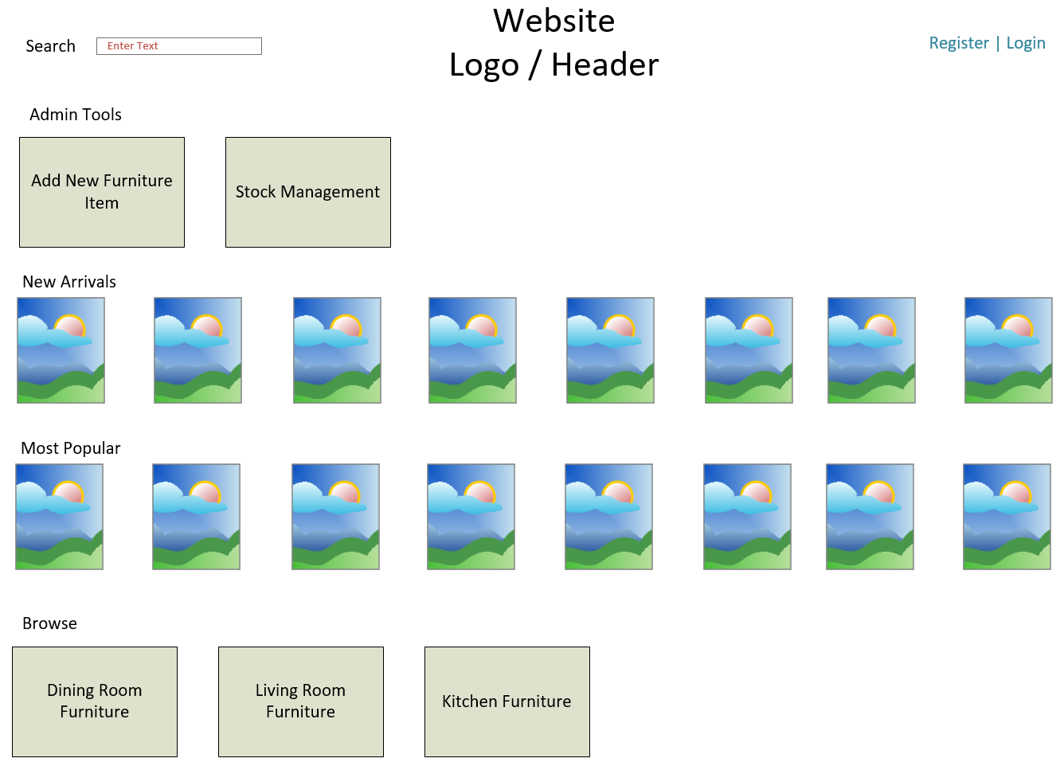

When in administrator mode the main page allows the administrator to:

* Do everything you can do in the normal main page
* A new section appears labeled “Admin Tools” with links to the Add Furniture Items page and the Stock Management page.

# Register / Signup Page:

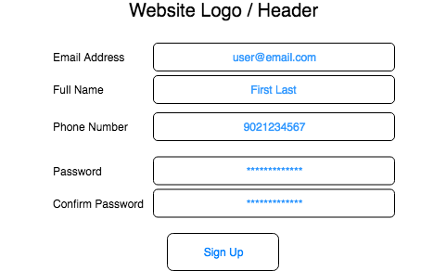

The registration page allows users to:

* Create new users in the system
* All of the fields in the page are required
* You must perform validation on the fields:
  + Emails cannot be empty strings, and must be unique in the database
  + Name cannot be empty strings
  + Phone numbers must be only digits
  + Passwords must meet some criteria (this is an excellent candidate for configurable business logic)
  + Passwords must match
* When users enter invalid data, they must be informed what’s wrong and how to fix it.
* When they successfully sign up, they should be redirected to the main page authenticated against their new user.

# Login Page:

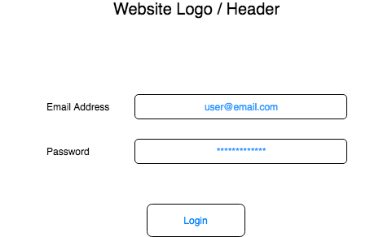

The login page must:

* Allow the user to login as a registered user via email and password OR as an administrator by entering “administrator” in the email address and the administrator password in the password box.
* The users email address and password are validated, if they match, they are logged into the system and redirected to the main page.
* Bonus points: Add the ability for users to retrieve or reset their passwords by clicking a “Forgot Password” link where they enter their email address and the system emails them a link to reset their password.

# Add/Edit Item Page

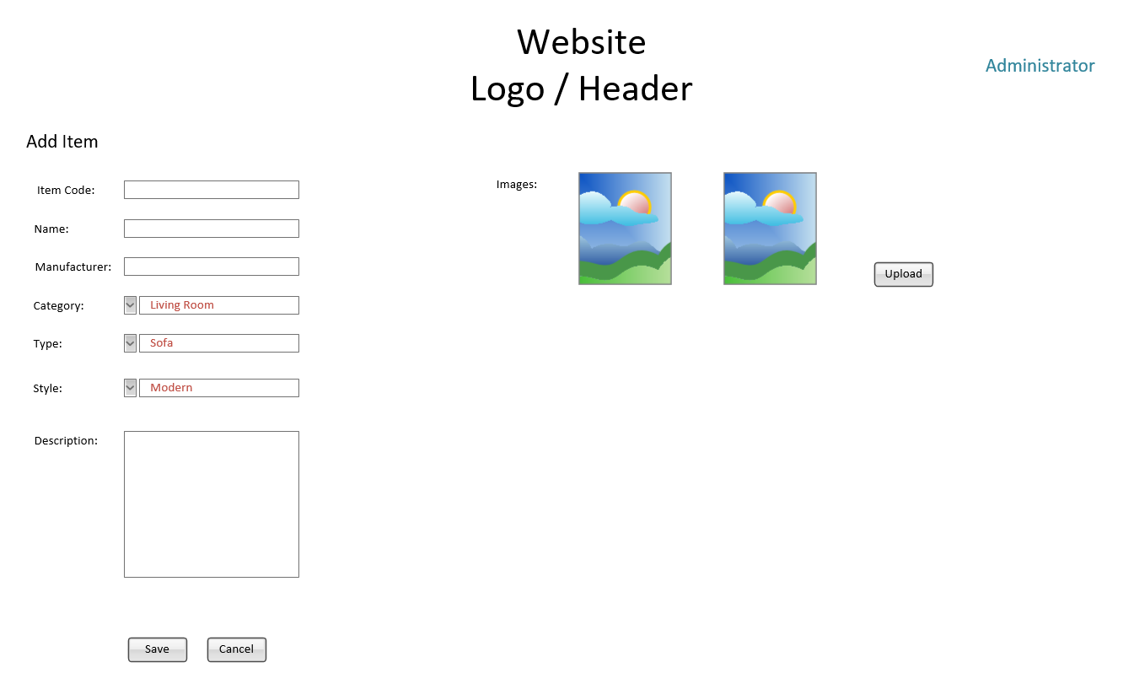

The add item page must:

* Change the context of what data is entered based on the dropdown. Each category has the following information:
  + Living Room Furniture:
    - Style (e.g. modern, contemporary etc.)
    - Name
    - Manufacturer
    - Item Code
    - Type: Sofa, Centre Table, Chair, Couch, etc.
    - Full description / title details
    - Images
  + Dining Room Furniture:
    - Style (e.g. modern, contemporary etc.)
    - Name
    - Manufacturer
    - Item Code
    - Type: Dining table, chair, etc.
    - Full description / title details
    - Images
  + Kitchen Furniture:
    - Style (e.g. modern, contemporary etc.)
    - Name
    - Manufacturer
    - Item Code
    - Type: Dining table, chair, etc.
    - Full description / title details
    - Images
* When the user clicks save all data is saved in the database for a new entry in the library. The photo can be uploaded to a file structure on the server or stored in the database.
* Cancel returns the user to the main page.
* The page must not allow the user to enter duplicate items in the database (items are considered duplicates depending on their context: a book is a duplicate if it has the same item code or name.

# Stock Management Page

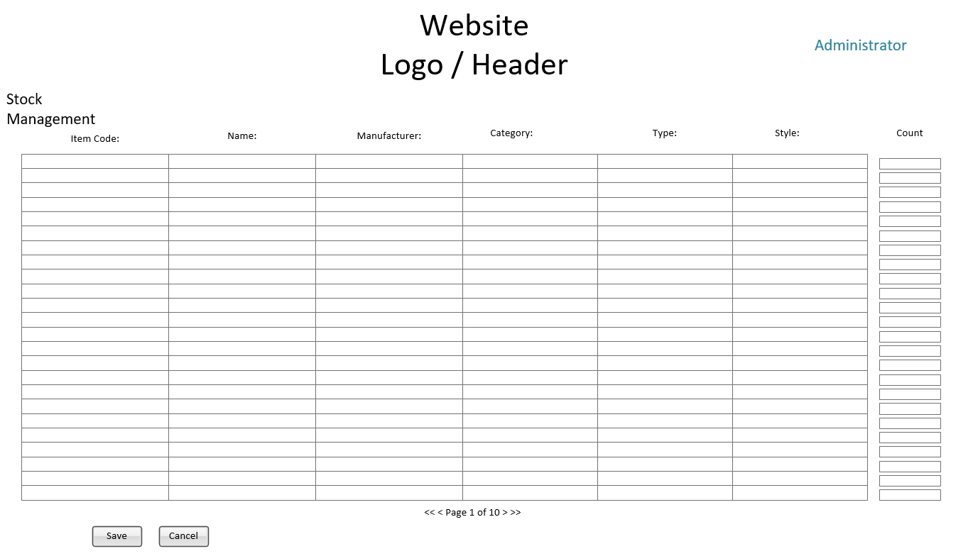

The Stock Management Page must:

* Display all out of stock items
* Pagination should be used to show if search returns more items than can be displayed on one page.
* Allow the user to click the column header and sort by the column (title, content type, user)
* Update quantity
* When the user clicks Update, all updated items’ stock is updated in the database. This then triggers a process that looks for pre orders on the items. Items with pre orders notify the buyer by email that the item is now available and automatically buys the item for that user.

# Item Details Page

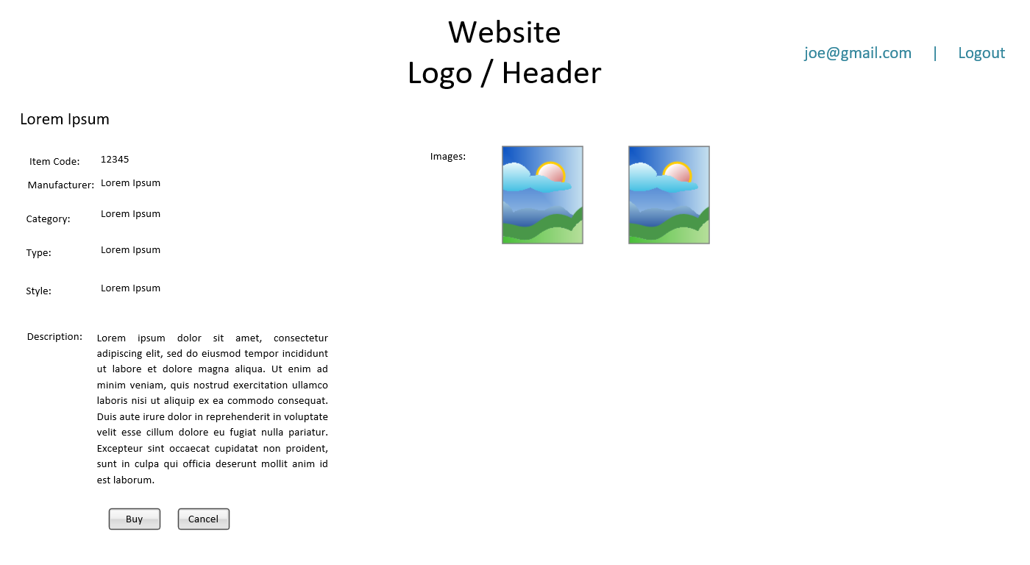

The Item Details Page must:

* Adapt to the context of the item to display the all available information.
* Display the item’s images.
* Detect the status of the item in the database, if it is available to buy the button at the bottom should say “Buy” and allow the user to buy the item. If the item is not available it should say “Pre order” to place a pre order on the item.
* If the Administrator is logged in the Buy button should be changed to “Edit” clicking which should redirect to Edit Item Details Page (which is similar to Add Item Details Page)

# Search Results Page

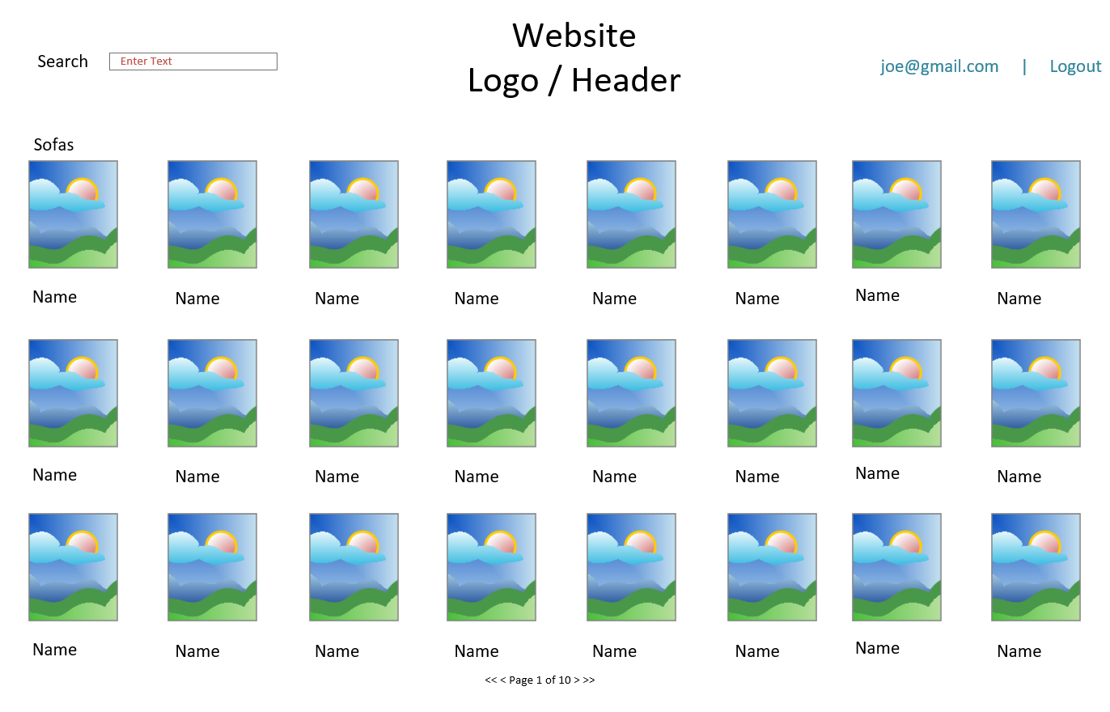

The search Results Page must:

* Display the results of the search, the item’s image, and the item’s title
* The results should be displayed in the context of the search. For example, if the user did an advanced search where they searched only dining room furniture only dining room furniture should be displayed.
* Pagination should be used to show if search returns more items than can be displayed on one page.
* Clicking any search result’s photo takes you to that item’s item details page.
* The search box should be prepopulated with the terms they used to search.

# Advanced Search Page

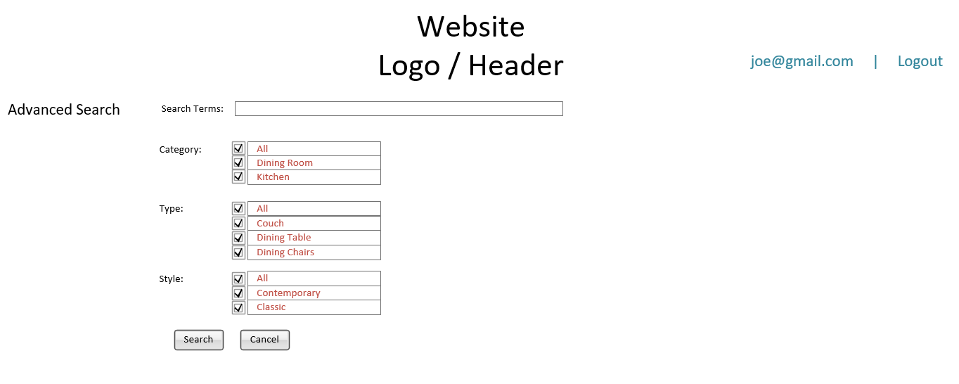

The Advanced Search Page must:

* Search terms are searched in all fields.
* Allow the user to search by a limited selection of content type, or fields that apply to the selected content type(s).
* Selecting ‘All’ for a field should select all values in that field, Unselecting ‘All’ for a field should unselect all values in that field. ‘All’ should be greyed checked if the selection in the field is some of the available fields.
* When the user selects a content type, the bottom group of checkboxes that apply to that content type become visible and the user can then select which fields of that content type to search. When the content type is not selected, the field box for that content type is hidden and all values are included.
* Searches executed from this page search ONLY the content types and fields selected by the user.
* Search results are displayed on the search results page as usual.
* No Search Term searched should return all items.

# Browse Page

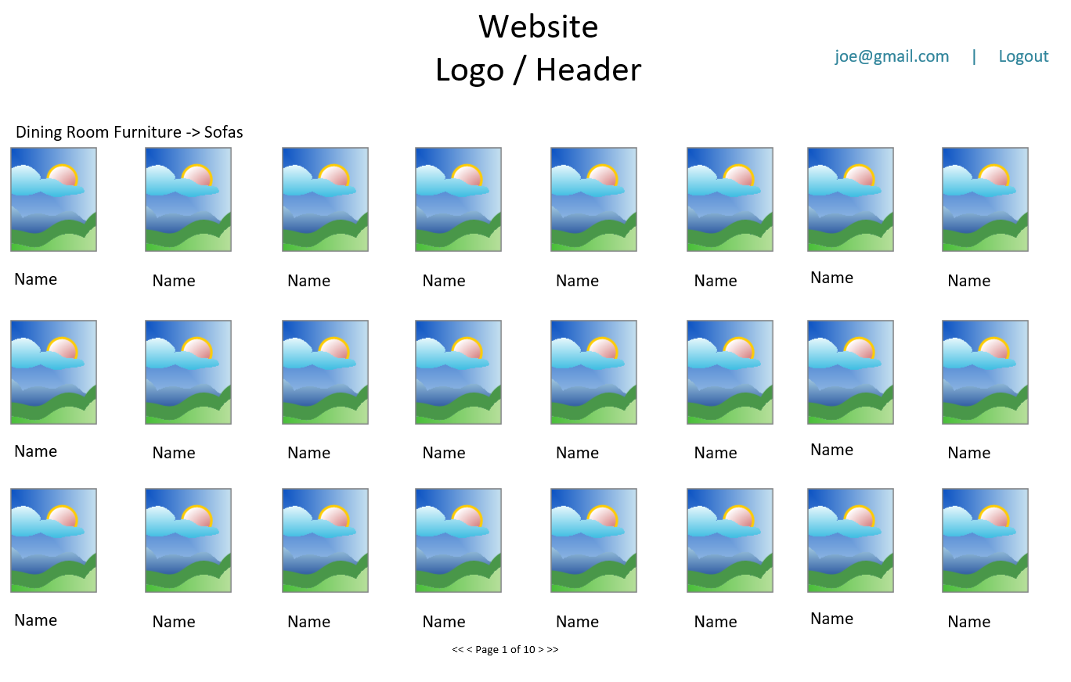

The Browse Page must:

* When the user selects “Dining Room Furniture”, “Living Room Furniture”, “Kitchen Furniture” from the main page, they should land on the starting point of the browse page. This lists all of the categories under the content type.
* Choosing one of the categories takes you to a browse page and a breadcrumb is displayed in the top left to show the user what category they are browsing.
* All items matching the content type and category the user selected are then displayed.
* Clicking any item takes you to that item’s item detail page.